SAE 2.03 Report

MILLAN Romain – CHARRADE Hugo – TREGUIER Ewan – PIERRE Geoffrey

## **Table of contents**

Table of contents 1

Introduction **2**

Configuration requise **2**

Software download & Installation procedure **3**

Updating the system 3

Installing Apache2 3

Installing MySQL 3

Installing PHP 4

Post-installation **4**

Apache2 Check 5

MySQL Check 5

PHP Check 6

Final check 6

Various questions **7**

How to uninstall all this ? 7

How to start all processes ? 7

How to stop all processes ? 8

How to restart all processes ? 8

Conflict between MySQL and MariaDB ? 8

# **Introduction**

The objective of this manual is to help you to download, install and verify the installation of the LAMP stack. The LAMP stack is essential for all full-stack development. You can install this stack on a virtual-machine or even on your personal server. The LAMP stack, consists of several distinct software as:

* An OS of linux type (Ubuntu).
* An HTTP web server (Apache).
* A database server (MySQL).
* A web development module (PHP).

# Required Configuration

At first we will configure the virtual machine as VirtualBox to be able to install the required software.

So that you can follow us in the installation of the LAMP system, we have installed the Ubuntu OS in version 20.04 on a virtual machine. For this, we have put 3GB (3072MB) on our machine with 10GB of storage for the hard disk.

Once the system is launched, you should follow the installation procedure and configure your password. **Don’t lose it**, because you will need it for the next steps.

Now that you have install your server or virtual machine on ubuntu, you can go to the next step ‘Software download & Installation procedure’.

# Software download & Installation procedure

### Updating the system

Now we will see how to download all the software of the LAMP stack. For this, we will start by updating the system. For this open your terminal and put this 2 lignes on:





Now, you are operational to install your LAMP stack.

### 

### Installing Apache2

Now that your system is well updated, you can start by installing Apache2 with this command line:



Several steps will happen. The first is to enter your admin password (*or sudo*), then there will be a confirmation or installation. After that, you will have to type ‘O’ and press the Enter key. Finally the Apache2 package will be installed and you will be back on your terminal.

### Installing MySQL

Once your web server is up and running, you need to carry on installing the stack. For this, we have to install MySQL. As for Apache, we will start by installing the 'mysql-server' package, with the following command line:



As for the installation to ‘apache2’, you will have to enter the password and confirm the installation with: enter ‘O’ and press Enter.

For better security, it’s necessary to execute a script that is included in the DBMS. It allows you to modify options that are not secure by default to this, execute this command line:



After executing this, you will have to make several entries in the terminal:

1. Your password.
2. The security level (*Generally 1*).
3. Enter your new password.
4. re-Enter your password.
5. Press Y and Enter.

### Installing PHP

We are going to proceed to the last step of the installation, the PHP installation. To this, enter this command line on your terminal:



As Apache and MySQL, you do enter the password and the installation confirmation.

# Post-installation

Once the installation of the LAMP stack is completed, we will check that the installation is achieved.

### Apache2 Check

We will start with the apache2 checking, thus we must enter this on the terminal:

If after the command execution you see this, your apache2 package is good:

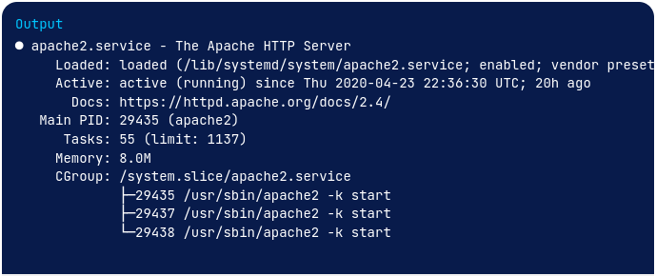

*The Apache2 server web will be operational if you're able to see this after the command execution.*

### MySQL Check

After the Apache2 checking, we will check the MySQL.

For this, you have to enter this command on your terminal:



Like Apache2, if you can see this, then the MySQL package is correctly installed:

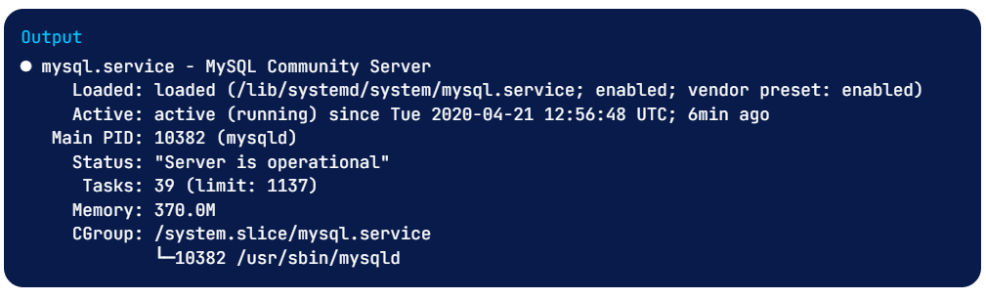

*If the MySQL server is not launch, you have to launch manually with this command:*



### PHP check

To conclude the verification, we will verify the correctly the installation of PHP, thus enter the commande:



You will see this, if this appears, the PHP package is correctly install.

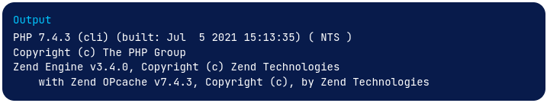

### Final check

For the last check before the end of this tutorial, you have to open your browser and write the address ‘localhost’. Once this is done, you should arrive on a similar page to the following one: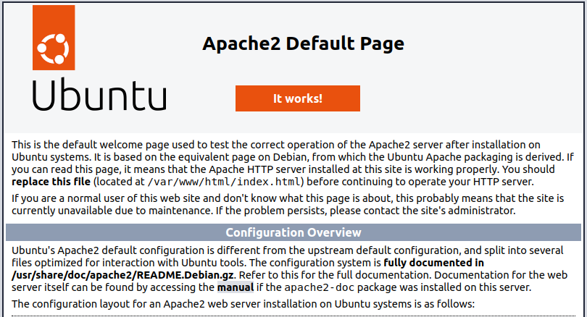

If you have this, the LAMP installation is done.

# Various questions

### How to uninstall it ?

To delete the LAMP stack ,you have to reopen your terminal and use the following commands to remove progressively all packages.





Or use the command:



### How to start all processes ?

For start all the processes you just have to use this command:





### How to stop all processes ?

For stop all processes of the LAMP stack, you have to use this commands:





### How to restart all processes ?

For stop all the processes you have to use this commands:





### Conflict between MySQL and MariaDB ?

If you have installed MariaDB and are looking to switch to MySQL, you may encounter an error of this kind when installing your package:

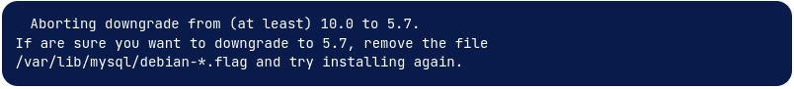

or maybe:



In this case, the easiest to do is to remove all config files of your databases.